Electro-Pneumatics Task Report
By Joseph Ashton, 27047440, for Industrial Automation, EGR3039

Stamping Machine
This section describes a method for automating the stamping machine detailed in Appendix 1 of the brief.  The operation adheres to the logical loop outlined in Figure 1. Once the start button `E0` is pressed the machine will for each block in the magazine:  - Clear the clamping area with `3A`  - Load & clamp a new block with `1A`  - Stamp the block with `2A`  The stamp is taken to be complete once the pressure in `2A` surpasses the threshold set by the pressure switch `P1` setting relay `K4` to active and restarting the process.  The circuit includes a PNOZ resettable safety relay that will disengage all actuators and stop the process in the case either of 2 emergency buttons are pressed. | 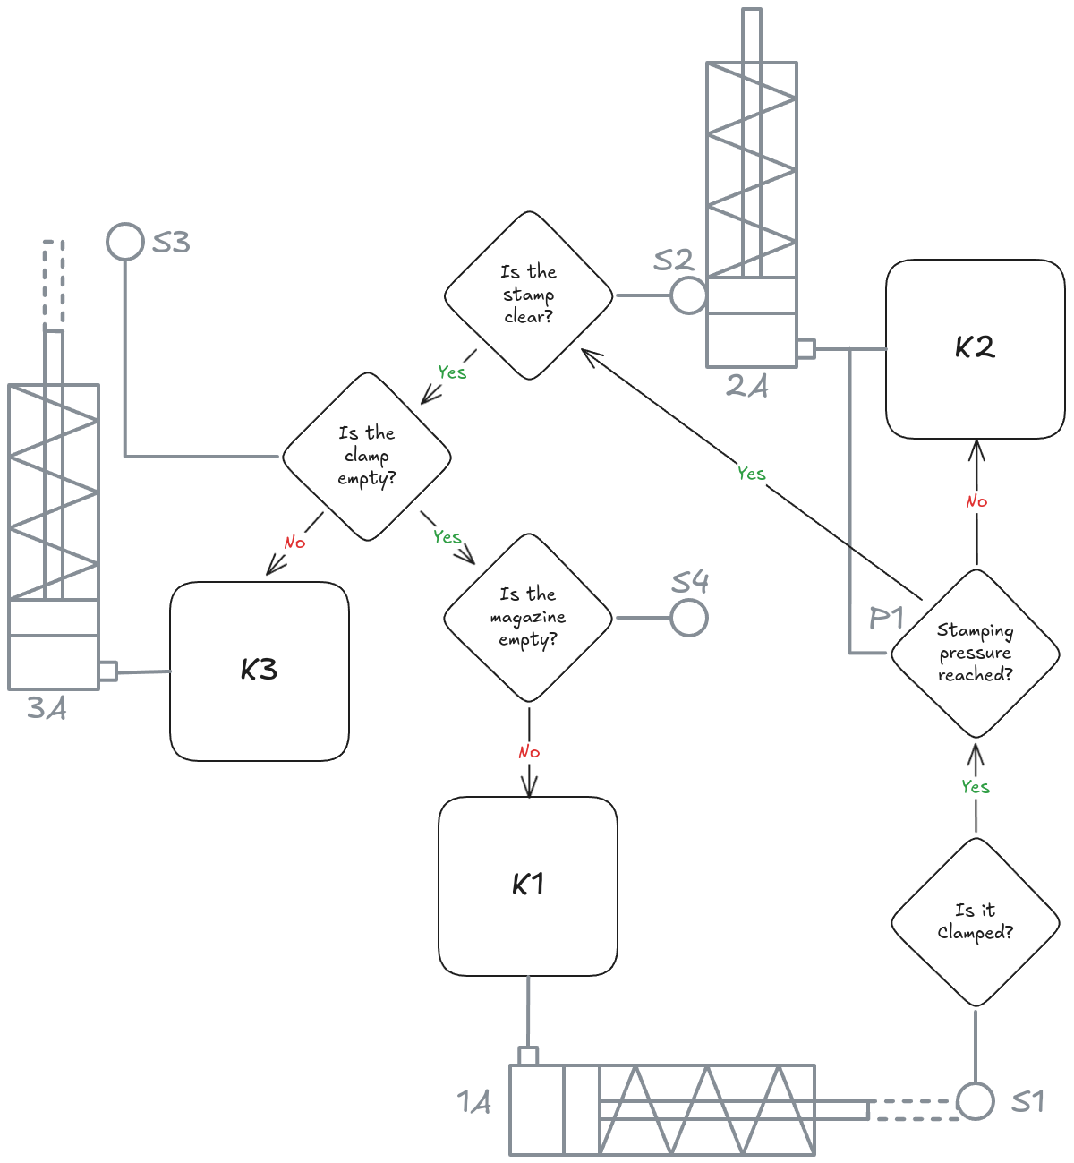Figure 1: Stamping machine automation flow chart
Components  - Single Acting Cylinder *3  - Position Switch *3  - Reed Switch  - Normally Open  - Dedicated Relay  - 3/2 Way Valve *3  - Solenoid Actuated  - Spring Return  - Pressure Switch  - PNOZ Safety Relay  - 2 switch re-settable  - 3 Contactors  - E Stop Button 2  - Latching  - Normally Closed  - Push Button (Closing)  - Normally Open  - Relay *4  - Valve Solenoid *3 | 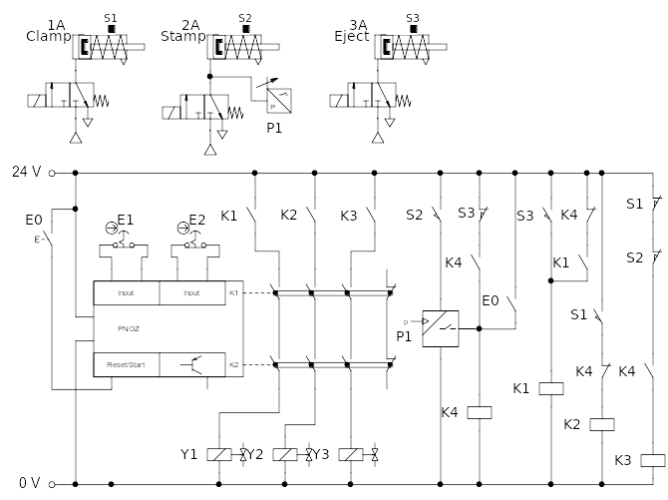Figure 2: Stamping machine automation FluidSIM diagram

Metal Casing
This section describes a method for automating the production of a bent sheet metal casing.
A sheet is fed by conveyor of driven rollers, these have enough friction to pull the sheet forward when it is free but not to crumple/tear it. When the sheet roll reaches a roller switch `B1`, the shear `A1` is actuated. This cuts a section of sheet while blocking the progress of the roll and allowing the cut section to advance.
Figure 3: (right) Shear automation flow diagram  Figure 4: (below) Folding automation flow diagram | 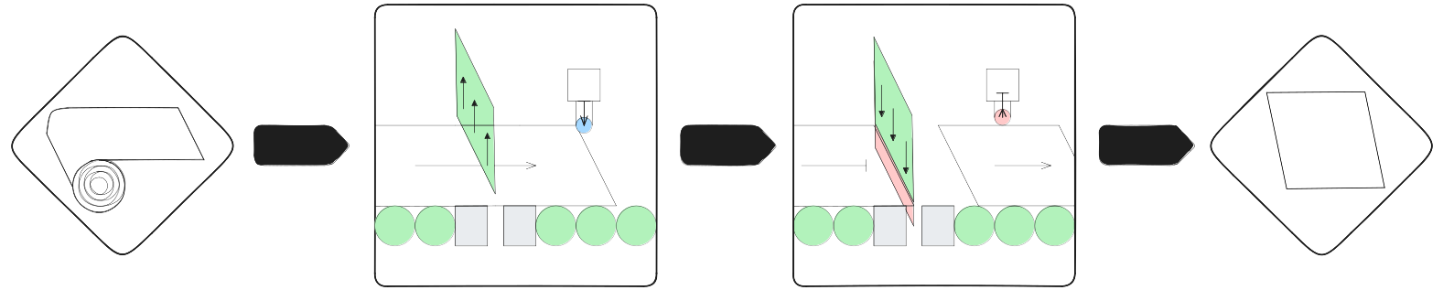
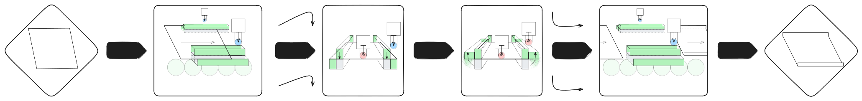
When this reaches `B2` a clamp is engaged then a folding mechanism. When the fold is achieved the folding mechanism is disengaged followed by the clamp. This allows the folded section to advance out of the clamp.
Components  - Single Acting Cylinder *4  - Position Switch *4  - Reed Switch  - Normally Open  - Dedicated Relay  - 3/2 Way Valve *3  - Solenoid Actuated  - Spring Return  - PNOZ Safety Relay  - 2 switch re-settable  - 3 Contactors  - E Stop Button *2  - Latching  - Normally Closed  - Push Button (Closing)  - Normally Open  - Contact Switch (Closing)  - 1P1T  - Normally Open  - Contact Switch (Change-over)  - 2P2T  - Relay *3  - Valve Solenoid *3 | 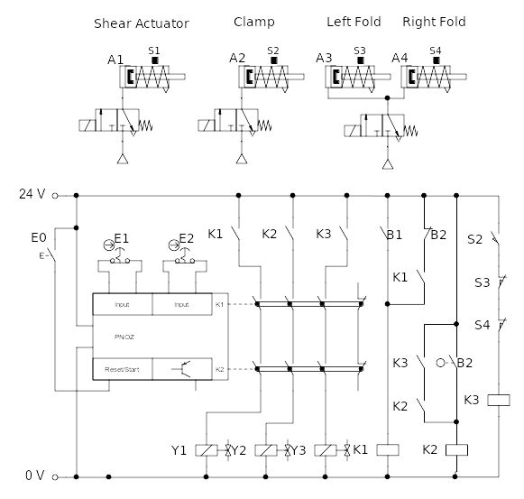Figure 5: Metal casing automation FluidSIM diagram
Note that the FluidSIM project file `BoxFoldingTask.fsprj` includes an additional circuit that simulates the progress of the sheets and triggers the buttons appropriately, this wouldn’t be necessary in practice.
It is assumed all reed switches used in both tasks are connected to a dedicated relay, these are not included in the circuit diagrams as FluidSIM inherits this behaviour by default. This is good practice to avoid directly loading the reed switches increasing the chance of melting them shut.

